The Forward Trust Job Description
Position Title | Head of Connections
Reports to | Executive Director Criminal Justice

Location: HMP Millsike - Full Sutton, Moor Lane, York, YO41 1PS

Introducing Forward Trust

We are The Forward Trust (formerly RAPt and Blue Sky), the social enterprise with charitable status that empowers people to break the often interlinked cycles of crime and addiction to move forward with their lives. For more than 25 years we have been working with people to build positive and productive lives, whatever their past. We believe that anyone is capable of lasting change. Our services have supported thousands of people to make positive changes and build productive lives with a job, family, friends and a sense of community.

Connections at Millsike

At HMP Millsike we are part of an innovative partnership with Mitie and People Plus to lead the prison. The Head of Connections is a flagship leadership role, a member of the prison’s Senior Leadership Team. Our aspiration is to scale up our Connections approach in the future.

The Connections Services bring Forward’s recovery expertise to desistance. They are whole person, whole system approaches involving group work, 1:1 and family support, with a heavy emphasis on lived experience.

Strategically unique The Head of Connections owns the establishment Drug, Family, and Visits policies. The services include visits, visitor’s centre and a flagship ‘More Than My Past’ Incentivised Substance Free Living house block.

With three service types; Family and Relationships, Drug Strategy, and More Than My Past we target personal, social, and community capital building to increase desistance and recovery. Each service type connects fully with the others, and the prison to provide a holistic complimentary approach that can be mixed and matched according to need for maximum impact..

Role/Team Overview

Reports to Executive Director Criminal Justice
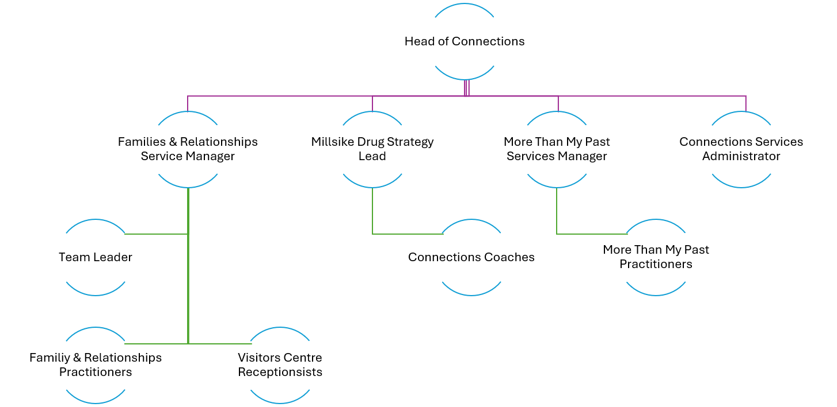

Accountabilities

Forward Trust Senior Leadership Team
- Member of SLT, attends meetings, completes actions and project work as required
- Proactively contributes to furtherance and success of mission, strategic and financial objectives, and as required
- Budget holder, meets financial targets set
- Achieves or exceeds workplan objectives, reporting progress quarterly effectively and accurately
- Ambassador of Forward Trust at all times
HMP Millsike Senior Leadership Team
- Member of SLT, attends meetings, completes actions and project work as required
- Proactively contributes to furtherance and success of establishment Annual Custodial Service Development Plan
- Owner of, leads and delivers compliance against Drug Strategy, Family and Relationships Strategy, Visits Operating Procedures
- Meets and exceeds HMIP expectations, risk and governance audit baselines, Family and Relationships Improvement Measure
- Maximises opportunities for business development / innovation through excellent relationship with Director, & holds boundaries avoiding contractual drift or mission dilution
- Maintains excellent working relationships with SLT and other operational / functional leads to ensure integration and successful delivery of Connections Services
Criminal Justice Directorate
- Contributes to thought leadership, using evidence of impact at HMP Millsike & own knowledge and understanding of desistance
- Proactively contributes to furtherance and success of criminal justice directorate
- Leads prison based business development opportunities
- Proactively promotes Connections, Forwards desistance approach, and criminal justice work and as required
Head of Connections
- Sets vision and cultural tone for HMP Millsike Connections Services
- Ensures Forward Trust is highly understood and promoted throughout establishment and especially by Connections staff
- Ensures high satisfaction of employee experience of leadership, being valued, and contributing to Forward Trust & HMP Millsike mission
- Ensures behaviours and values of Connections staff exemplify Forward Trust at all times
- Ensures high degree of lived experience led activity, co creation, review and participation in services at all times
- Ensures close relationship with and high visibility of More Than My Past Ambassadors in Connections Services
- Excellent relationship Management, creates and maintains partnerships and relationships with others to further, support, develop and enhance the Connections Services success
Families and Relationships
- Line manager to Families and Relationships Service Manager
- Ensures Families and Relationships team is well resourced with excellent behavioural, cultural and values alignment to Forward Trust and desistance and recovery approaches
- Owner of establishment Family and Relationship strategy and Family and Relationship Performance Measure
- Ensures quality and contractual delivery of Relationships Matter, Parenting Programme, and MPACT
Visits
- Owner of Visits Operating Procedures
- Ensures Visitors Reception team is well resourced with excellent behavioural, cultural and values alignment to Forward Trust and desistance and recovery approaches
- Innovates visitor’s centre and visitors approach beyond current best practice
- Ensures Connections Services and Forward Trust are well known and understood by Visitors to HMP Millsike
- Manages contractual relationship and delivery, including compliance with regulations, of Café provider including open book reporting and sharing of profit from sales
Drug Strategy
- Line Manager to establishment Drug Strategy Lead
- Ensures Connections Coaches team is well resourced with excellent behavioural, cultural and values alignment to Forward Trust and desistance and recovery approaches
- Owner of establishment Drug Strategy
- Exceeds HMIP expectations
- Ensures demonstrably positive impact on supply, demand, harm reduction and innovation
- Ensures close relationship with and high visibility of Forward Connect & More Than My Past Ambassadors in Connections Services
- Ensures client pathway to Forward Trust Residential Rehabilitation particularly Clouds House
- Ensures annual establishment participation in live streamed reunion events
- Ensures ISFL delivery to excellent standard
More Than My Past
- Line Manager to More Than My Past Service Manager
- Ensures More Than My Past team is well resourced with excellent behavioural, cultural and values alignment to Forward Trust and desistance and recovery approaches
- Ensures high quality standards and contractual delivery of More Than My Past programme
- Owner of More Than My Past ISFL Houseblock operating procedures and quality of delivery
- Ensures close relationship with and high visibility of More Than My Past Ambassadors in Connections Services
Contractual Compliance & Impact
- Responsible for delivery of all contract deliverables / obligations between Mitie and Forward Trust
- Ensures payment penalty is minimised through excellent governance and service delivery
- Provides excellent accurate quarterly contract and impact report to Mitie
- Ensures deliverables are measured and reports impact accurately and compellingly
- Manages risk effectively

Role Criteria
Criteria Requirement
E | Essential Criteria
D | Desirable Criteria
Criteria Measure
A | Application
I | Interview
T | Test
Below is a list of the criteria required to apply for this role; please address each of these points in your application.

Experience, Skills & Knowledge
 | Essential / Desirable | Tested At
Significant leadership experience, in a custodial environment.  Custodial operational experience such as managing custodial elements like visits, residential or therapeutic environments. | Essential | Application  Interview
Experience managing contractual service delivery in Criminal Justice settings, ideally of The Dynamic Framework, Privately Managed Prisons and / or Public Sector Prisons. | Essential | Application  Interview
Experience managing a £mil budget with experience managing contractual payment dependency clauses | Essential | Application  Interview
Experience of delivery in a highly regulated, audited and inspected environment, with a track record of delivering high standards, consistent compliance, and exceeding expectations. | Essential | Application  Interview
Excellent leadership organisational skills including project, programme, budget and action planning and delivery. | Essential | Application  Interview
Excellent enabling skills, demonstrably able to provide stakeholders with the necessary understanding and resources to succeed, managing performance throughout. | Essential | Application  Interview
Excellent relational and relationships skills. Skilled in forming & maintaining diverse partnerships, alliances, and relationships, with many types of stakeholders. Excellent stakeholder management, including keeping people informed, making sure things happen, negotiating, and boundary management. Experience of managing subcontractor arrangements. | Essential | Application  Interview
Excellent skills in structuring case management and impact reporting, ensuring that we record and demonstrate completion of the work we are committed to, and can confidential report on impact, trends, and dependencies and make evidence led decisions and recommendations. | Essential | Application  Interview
Excellent communication skills able to simplify complexity, use data, and adapt approach according to audience and purpose of communication. | Essential | Application  Interview
Knowledge of desistance theories and approaches, with a qualification a distinct advantage. | Essential | Application  Interview
Knowledge of Narrative Therapy / Theory / Approaches | Highly Desirable | Application  Interview

