Forward Trust Job Description

Position Title | Recovery Navigators | Reports to | Team Leader
Location: This role will be remote based with requirement to travel across London boroughs, meeting service users at hubs and probation services mandated locations.

Introducing Forward Trust:
We are The Forward Trust (formerly RAPt and Blue Sky), the social enterprise with charitable status that empowers people to break the often interlinked cycles of crime and addiction to move forward with their lives. For more than 30 years we have been working with people to build positive and productive lives, whatever their past. We believe that anyone is capable of lasting change. Our services have supported thousands of people to make positive changes and build productive lives with a job, family, friends and a sense of community.
Forward Trust now delivers services within the Commissioned Rehabilitative Services (CRS) as part of the Ministry of Justice’s new probation system, procured by Regional Probation Directors to provide flexible, responsive services to help break the cycle of reoffending.
Role and Team Overview:
You will be working remotely as part of a flexible, multi-disciplinary team, covering clusters across London as a Recovery Navigator (RN) in the Dependency and Recovery Services as part of the CRS probation system.
You will carry a diverse caseload of adult male prison leavers and those on community orders within the Probation services, supporting to implement their action plan and navigate their recovery journey, building trust, and providing support/continuity of contact and signposting. You will be responsible for completing comprehensive assessments, creating a collaborative action plan, delivering structured one to one, group work/virtual sessions, whilst maintaining accurate record keeping throughout.
RN’s will be multi-skilled/trained to provide a range of support/interventions across all complexity levels and be able to work across London (not just in allocated cluster region), providing flexibility and resilience against changing demand.
You will deliver services which enhance access to treatment as well as providing additional support and guidance meeting the needs of those People on Probation (POP) whose substance use disorders often co-occur alongside other mental illnesses and other complex needs.
The Dependency and Recovery Service should not duplicate provision where Clinical Commissioned Services are already in place, instead you will work to ensure POP’s access and sustain engagement with statutory and existing provision to include building motivation, practical assistance and ongoing support and/or achieve controlled dependent behaviour or abstinence with the aim to reduce re-offending.
Some RN’s will be nominated subject matter experts (SME) in particular vulnerable groups (e.g. BAME) or needs (e.g. chemsex), providing support to colleagues across the team.
You will be responsible for adhering to the targets set by Forward and the local commissioners. Co-operative working relationships with other partner agencies and probation staff are vital to this role.
In addition to Monday-Friday we will provide out of hours support, so some degree of flexibility will be required (eg. evenings 5– 9pm/weekends 9am–5pm) provided virtually 1:1 and through an online and telephone helpline.
You may at times be required to attend our head office for training.
Principal Accountabilities:

Service Delivery
- Carry out risk and initial/comprehensive assessments, develop and maintain action planning and complete session and end of service reports.
- Deliver both 1:1 sessions and group work/programme facilitation as identified on action plan
- Maintain live records as per requirements of the Refer and Monitor system
- Build and maintain effective working relationships, communication and liaison with all stakeholders; including sign posting to relevant agencies to enhance POP access and support.
- Participate and contribute in key meetings such as team meetings and multi-disciplinary reviews, sharing information appropriately
- Update the Refer and Monitor system daily with information indicating changes in risk including:
  - Non-attendance,
  - Poor engagement with activity.
  - Threatening behaviour.

Performance Management
- To comply with contractual service level agreements/key performance targets, ensuring all timeframes are met as per obligations
- Ensure D&R interventions are facilitated to the standard required by Forward Trust and authority in accordance with any relevant manuals/framework.
- Plan and manage caseload effectively, making sure that POP are prioritised appropriately and seen in a timely manner.
- Contribute to the overall smooth running of the service by being proactive and solution focused.

Quality and Safety
- Raise/report safeguarding concerns in a timely manner to statutory agencies; including alerting Probation and all designated safeguarding leads to any risks identified.
- Follow all policies ensuring effective and immediate record keeping where applicable
- Actively input into multi-disciplinary reviews for POP’s where required
- Maintain all service user records in an accurate, clear, professional and legible fashion
- Ensure any interaction pertaining to service user is documented on all records
- Alert the Team Leader/manager immediately to any significant risks or problems arising or observed within the services
- Effectively manage information, particularly confidential information, within statutory duties and information governance policies.
- Promote and ensure departmental compliance with all relevant legal, regulatory, and ethical responsibilities.
- Ensure all incidences/near misses are reported via Ulysses’ system in accordance with policy
- Ensure adherence to lone working policy and local processes

Administration
- Ensure case management documentation is maintained to the expected audit standards.
- Ensure data capture systems are fully accurate and completed on day of activity
- Complete and maintain SMART action plans and assessments to the required standards.
- Complete session and end of service reports as per required framework
- Complete signposting/referral forms as required

Systems and Policy
- Use IT efficiently to support your role.
- Ensure you have agreed working protocols set between multi-disciplinary agencies and share information appropriately.
- Make full use of the information systems available to you such as Intranet, email.
- Save all relevant work on share-point
- Report any issues relating to IT as per process
- Maintain any Cascade System requirements you are responsible for on the HR personnel system
- Ensure during induction period you familiarise yourself with all Forward Trust policies
- Keep up to date with relevant legislation changes, best practice and read all communication received

Other
- Take on other reasonable tasks and responsibilities as deemed appropriate by Line Management
- To actively identify any training requirements, continued professional development and support needs and inform line manager
- To independently travel around whole region as required

Required Skills and Competencies

Criteria Requirement
E | Essential Criteria
D | Desirable Criteria
Criteria Measure
A | Application
I | Interview
T | Test
Below is a list of the criteria required to apply for this role; please address each of these points in your application.
Knowledge, Skills and Experience
Knowledge and experience of the criminal justice sector. | E | A/I
Excellent experience of substance misuse field and/or experience of working in a related field or similar field | E | A
Demonstrable experience of managing high caseloads, carrying out risk/ comprehensive assessments, SMART action plans and effective case records | E | A/I/T
Experience of delivering both 1:1 and group-work interventions using motivational techniques and trauma informed approaches | E | A/I
Experience of working with treatment and/or healthcare services | E | A/I
The ability to set and stick to professional boundaries | E | A/I
Ability to work effectively with key partners in order to successfully deliver outcomes | E | A/I
Demonstrate the ability to organise workload , ensuring effective time management and prioritisation to meet targets | E | A/I
Understanding of, and commitment to, the principles of equal opportunity and GDPR requirements including client confidentiality | E | A/I
Experience of strong communication skills with people from a range of backgrounds in a sensitive, supportive and professional manner | E | A/I
Personal experience of addiction/imprisonment (Addicts in recovery should have at least 3 years clean time. Ex-prisoners, should have been released at least 5 years ago). | D | A
Experience of providing counselling services to prisoners, or those with Health and Wellbeing, or drug and / or alcohol problems | D | A
A thorough knowledge of and commitment to the 12-step process of recovery from addiction/recovery agenda | D | A/I
Knowledge of the Recovery Agenda. | D | A
Personal Attributes
Proactivity – Quick thinking with a high level use of initiative | E | I
Resilience – Solves problems, takes learning on board from mistakes to aid personal and professional growth | E | I
Adaptability – Can work in fast-paced changing environments | E | I
Confidence – Has confidence in own abilities, has good eye contact and able to communicate clearly and concisely | E | I
Team Work – Works in harmony with colleagues to deliver results | E | A/I
Open to Feedback - Open to constructive feedback in order to further develop | E | I
Qualification
Level 3 substance misuse related qualification/working knowledge of substance misuse services or relevant experience in a comparable role | E | A/I
Any qualification in advice & guidance, counselling or PTTLLS | D | A
Previous experience as a subject matter experts (SME) in particular vulnerable groups (e.g. BAME) or needs (e.g. chemsex), | D | A/I

Forward Trust Vision, Mission, and Values:


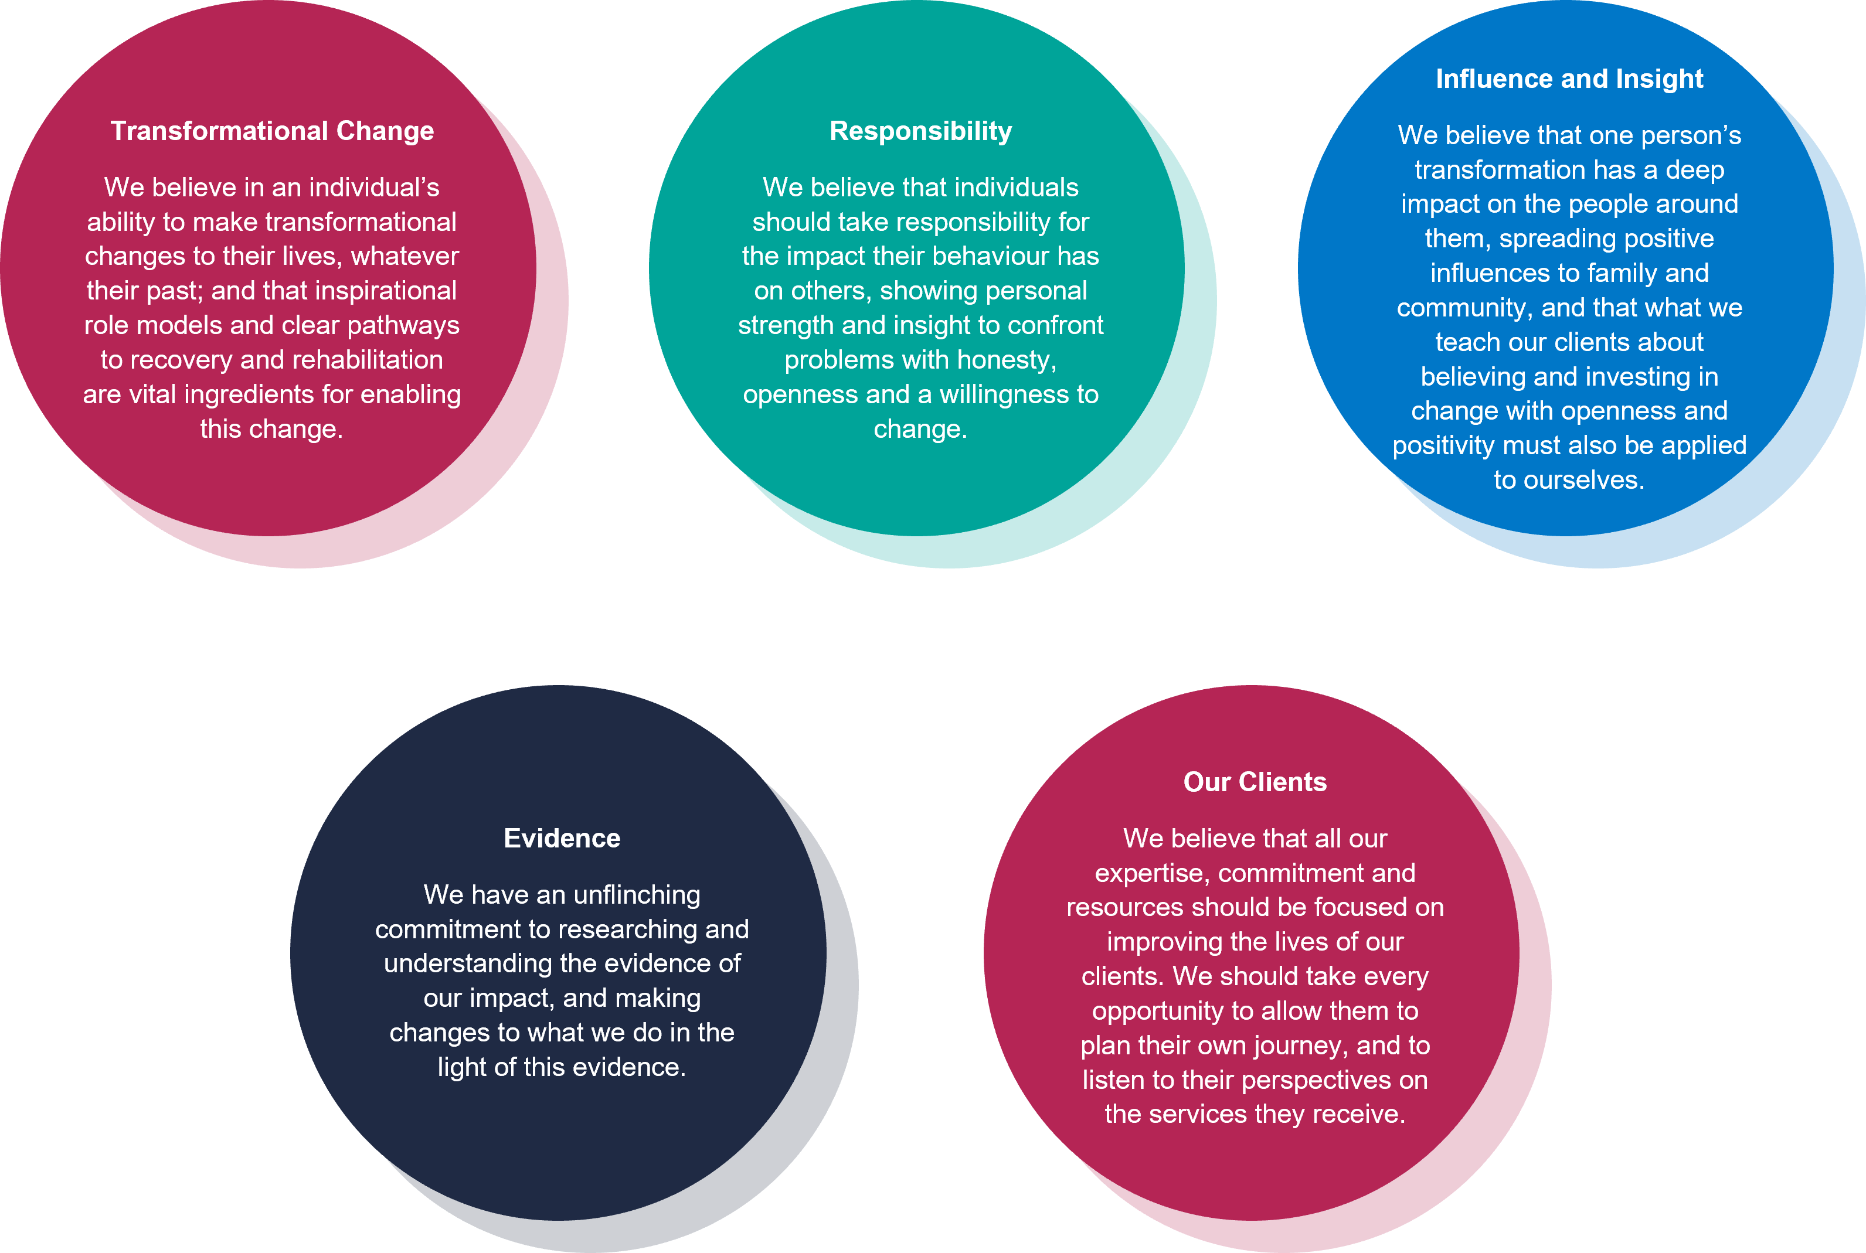
Our Values:

