Forward Trust Job Description

Position Title | Lived Experience Co-Ordinator | Reports to | Team Leader
Location: This role will be remote based with requirement to travel across a cluster of London boroughs at hubs and probation service mandated locations

Introducing Forward Trust:
We are The Forward Trust (formerly RAPt and Blue Sky), the social enterprise with charitable status that empowers people to break the often interlinked cycles of crime and addiction to move forward with their lives. For more than 30 years we have been working with people to build positive and productive lives, whatever their past. We believe that anyone is capable of lasting change. Our services have supported thousands of people to make positive changes and build productive lives with a job, family, friends and a sense of community.
Forward Trust now delivers services within the Commissioned Rehabilitative Services (CRS) as part of the Ministry of Justice’s new probation system, procured by Regional Probation Directors to provide flexible, responsive services to help break the cycle of reoffending.
Role and Team Overview:
You will be working remotely as part of a flexible, multi-disciplinary team, covering boroughs across London as a Lived Experience Co-Ordinator in the Dependency and Recovery Services as part of the CRS probation system.
You will contact new POP, providing an information pack, promote the benefits of working with us and introduce them to our Lived Experience Peers (LEPs). You will establish a referral pathway and continually promote our service in London via locally tailored marketing/publicity, e.g., roadshows/events, workshops, surgeries, local media, leveraging material from our ongoing “More Than My Past” campaign, giving voice to people with lived experience, and reinforcing the message that recovery is possible
Our aim is to reduce re-offending through a comprehensive, holistic and person centred package of support. Our service is tailored to meet individual needs by delivering a range of programmes within the Dependency and Recovery framework.
This role is primarily responsible for the development and management of the LEP’s Mentor service You will be required to recruit, train and supervise day to day management of volunteers and LEP’s
You will also co-ordinate team meetings, update training and provide supervision for LEP’s and Volunteers and where applicable support with Level 2 peer mentoring qualification
.

You will be required to manage a diverse case load with a range of complexities and risk levels . You will be responsible for completing comprehensive assessments, creating a collaborative action plan, maintaining accurate record keeping throughout.
You will be responsible for adhering to the targets set by Forward and the local commissioners. Co-operative working relationships with other partner agencies and probation staff are vital to this role.
In addition to Monday-Friday we will provide out of hours support, so some degree of flexibility will be required (eg. evenings 5– 9pm/weekends 9am–5pm) provided virtually 1:1 and through an online and telephone helpline.
You may at times be required to attend our head office for training.

Principal Accountabilities:

Service Delivery
- Carry out risk, initial/comprehensive assessments to inform action planning.
- Deliver both 1:1 sessions and group work/programme facilitation as identified on action plan
- Provide continual exposure to real-life success stories (peer supporters, videos, podcasts) of recovery from all backgrounds, making the impossible seem possible through lived experience, support PoP to identify their personal/intrinsic motivation, their ‘reasons to recover’, capturing this in a note to self, which they can keep on a card in their wallet or on their phone as a constant reminder.
- Provide 24/7 access (and communication devices if required via Tesco digital poverty scheme) to Kaizala (Microsoft GDPR-compliant version of WhatsApp) chat groups for peer support and advice (RN-monitored)
- Promote membership of Forward Connect recovery community (charitably-funded, illustrated opposite), supporting Forward clients leaving London prisons and others in recovery through access to mutual aid meetings, social activities, Fuse app (e.g. meditation tutorials, inspirational videos) and benefits (e.g. laser-based tattoo removal.
- Adapting delivery/contact methods to suit the PoP; meeting them “where they are at” (where safe) with delivery time flexibility
- Train service users to become LEP’s and to provide the support and supervision and guidance they require
- To work in partnership with all staff to identify and manage risk in relation to LEP’s, including incident management
- To work in partnership with all staff responsible for the clients receiving support and intervention
- To develop relationship with clients receiving support, aimed at achieving the goals defined in their individual action plan
- Work with the team within the appropriate regulatory framework to meet the needs of the Service
- Build and maintain knowledge of integrated services and make links with relevant prison departments/community to promote the services’ objectives
- Ensuring the co-ordination and maintenance of relationships with clients and LEP’s, identifying any shortfalls in service delivery and ensuring they are dealt with appropriately and flagged to senior colleagues
- Support LEP’s, matching and regularly review progress with mentors and mentees
- · Involve and support peer mentors and volunteers in wider project activities including administration, promotion, recruitment and training delivery
- · Utilise agreed outcome monitoring tools to capture outcomes for mentors and mentees using feedback to support continuous improvement

Performance Management
- You will identify and pursue further opportunities to champion services to recruit, train and support Peer mentors from within the service user population
- You will coordinate the provision of support and meet the needs of clients for the Services and monitoring outcomes and performance through regular and effective supervision with line management
- You will champion the utilisation of the services to ensure effective uptake and effective deployment of resources within the service
- You will work with senior colleagues to facilitate the delivery of peer mentor services
- You will build and maintain excellent internal relationships across the Services to achieve outputs in line with the service provided for clients
- You will support and co-ordinate to ensure that the necessary logistics for the peers are being delivered administratively
- You will work with colleagues in the prison and community to support events, promote awareness and coordinate the activities of the team
- To ensure the development and delivery of peer mentor services that promote emotional resilience and mental wellbeing using person centred practices in line with the service needs
- To maintain accurate administration of peer mentor services delivery and outcomes to meet client needs and relevant legislation

Departmental Management
- Build and maintain effective relationships, communication and liaison with all stakeholders; including sign posting to relevant agencies
- Meet targets and deadlines in accordance with contractual standards.
- Contribute to the overall smooth running of service by being proactive and solution focused.
- Attendance and contribution at all key relevant meetings as required
- Arrange peer-led workshops/meetings (e.g. yoga, book clubs)
- Arrange Meet and Greet (for prison leavers)
- Kaizala app chat groups (moderated peer support forums) to be established
- Embed Forward Connect and mutual aid groups into contract

Quality and Safety

- To ensure quality standards are maintained and adherence to the targets set by Forward and the local commissioners
- Raise/report safeguarding concerns in a timely manner to statutory agencies; including alerting Probation and all designated safeguarding leads to any risks identified.
- Follow all policies ensuring effective and immediate record keeping where applicable
- Actively input into multi-disciplinary reviews for service users where required
- Maintain all service user records in an accurate, clear, professional and legible fashion
- Ensure any interaction pertaining to service user is documented on all records
- Alert the Team Leader/manager immediately to any significant risks or problems arising or observed within the Personal Wellbeing service
- Effectively manage information, particularly confidential information, within statutory duties and information governance policies.
- Promote and ensure departmental compliance with all relevant legal, regulatory, and ethical responsibilities.
- Risk assess LEP mentoring activities and follow best practice guidelines to ensure mentor and mentee safety
- Ensure all incidences/near misses are reported via Ulysses’ system in accordance with policy
- Ensure adherence to lone working policy and local processes

Administration
- Ensure case management/peer mentor documentation is maintained to the expected audit standards.
- Ensure data capture systems are fully accurate and completed on day of activity
- Complete and maintain SMART action plans and assessments to the required standards.
- Complete session and end of service reports as per required framework
- Complete signposting/referral forms as required

Systems and Policy
- Use IT efficiently to support your role.
- Ensure you have agreed working protocols set between multi-disciplinary agencies and share information appropriately.
- Make full use of the information systems available to you such as Intranet, email.
- Save all relevant work on share-point
- Report any issues relating to IT as per process
- Maintain any Cascade System requirements you are responsible for on the HR personnel system
- Ensure during induction period you familiarise yourself with all Forward Trust policies
- Keep up to date with relevant legislation changes, best practice and read all communication received

Other
- Take on other reasonable tasks and responsibilities as deemed appropriate by Line Management
- To actively identify any training requirements, continued professional development and support needs and inform line manager
- To independently travel around London as required

Required Skills and Competencies

Criteria Requirement
E | Essential Criteria
D | Desirable Criteria
Criteria Measure
A | Application
I | Interview
T | Test
Below is a list of the criteria required to apply for this role; please address each of these points in your application.
Knowledge, Skills and Experience
Knowledge of the issues facing service users in the criminal justice sector. | E | A/I
Previous experience of providing a peer support service to this or a similar client group or working closely with volunteers | E | A
Demonstrable experience of managing high caseloads, carrying out risk/ comprehensive assessments, SMART action plans and effective case records | E | A/I/T
Experience of delivering both 1:1 and group-work interventions using motivational techniques | E | A/I
Experience of providing training and support for peer support services to prisoners, or those with drug or alcohol problems | E | A/I
The ability to set and stick to professional boundaries | E | A/I
Ability to work effectively with key partners in order to successfully deliver projects | E | A/I
Demonstrate the ability to organise workload , ensuring effective time management and prioritisation to meet targets | E | A/I
Understanding of, and commitment to, the principles of equal opportunity and GDPR requirements including client confidentiality | E | A/I
Experience of strong communication skills with people from a range of backgrounds in a sensitive, supportive and professional manner | E | A/I
Personal experience of addiction/imprisonment (Addicts in recovery should have at least 3 years clean time. Ex-prisoners, should have been released at least 5 years ago). | D | A
Personal Attributes
Proactivity – Quick thinking with a high level use of initiative | E | I
Resilience – Solves problems, takes learning on board from mistakes to aid personal and professional growth | E | I
Adaptability – Can work in fast-paced changing environments | E | I
Confidence – Has confidence in own abilities, has good eye contact and able to communicate clearly and concisely | E | I
Team Work – Works in harmony with colleagues to deliver results | E | A/I
Open to Feedback - Open to constructive feedback in order to further develop | E | I
Qualification
A relevant qualification in criminal justice/social care or relevant experience in a comparable role | E | A/I
Any qualification in advice & guidance, counselling or PTTLLS | D | A

Forward Trust Vision, Mission, and Values:


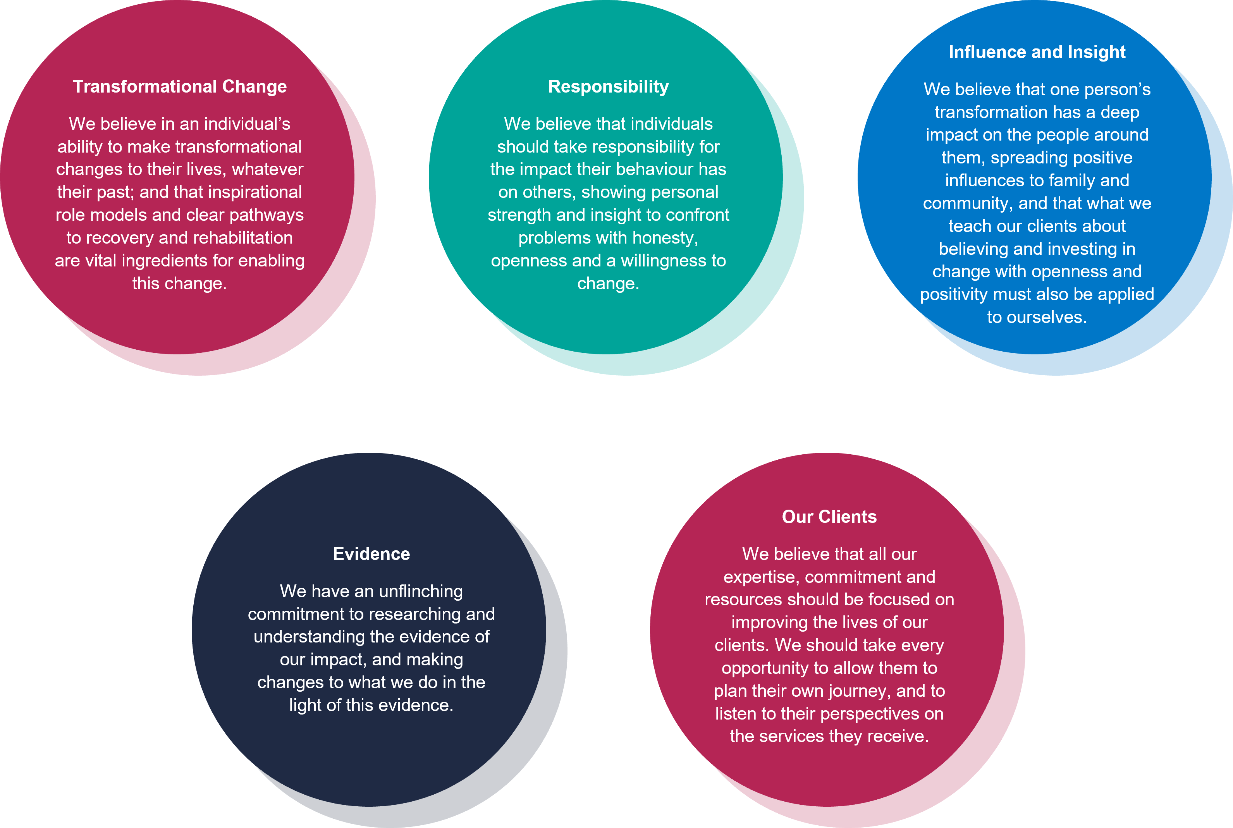
Our Values:

