Forward Trust Job Description

Position Title | Prison Link Worker | Reports to | Team Leader
Location: Onsite London Prison: HMP Brixton and HMP Wandsworth

Introducing Forward Trust:
We are Forward, the social enterprise that empowers people to break the cycle of crime or addiction to move forward with their lives. For more than 25 years we have been helping people to build positive and productive lives, whatever their past. We believe that anyone is capable of lasting change. Our services have supported thousands of people to make positive changes and build productive lives with a job, family, friends, and a sense of community.
Forward Trust deliver Commissioned Rehabilitative Services (CRS), directly for HMPPS. Currently we deliver Accommodation, Dependency and Recovery and Personal Wellbeing. Accommodation is delivered in Dyfed-Powys, South Wales and Gwent. Dependency and Recovery in London and Yorkshire and The Humber. Personal Wellbeing in Bedfordshire, Cambridgeshire, Essex, Lincolnshire, Norfolk, Sussex, Surrey; and as a subcontractor in Kent and Cheshire.
Role and Team Overview:
As a Prison Link Worker in the Dependency and Recovery Service, you will be working within a hybrid model as part of a flexible, multi-disciplinary team, working predominantly from HMP Brixton and HMP Wandsworth Your role involves working with men in a prison setting prior to their release, managing them through the gate, then post release into the community. This is an in-person service, and you will be expected to work day-to-day from the locations mentioned above.
This role is key to supporting the continuity of care agenda, ensuring smooth transition through the gate from prison to community treatment and other services. It is vital that you build close working relationships with the prison substance misuse teams.

You will be targeting boroughs with low continuity of care by providing meet and greet/enhanced support for releases that have a history of non-engagement, with daily calls/appointment reminders and accompanying clients to probation/substance misuse appointments.

You will need to manage risks associated with transition to community, e.g. treatment drop-out, harm minimisation/overdose and attend key initial appts. Overall, you will need to support service user to successfully integrate into community by successful engagement with statutory and voluntary services both in person and virtually.

You will need to understand the barriers and opportunities to improve continuity of care (pre-release contact, reviewing release plans with prison substance mis-use worker, identifying alternative points of contact for the SU on release (e.g. family/friends), ensuring a community substance misuse appt has been made.
You will need to be confident working autonomously in prison settings representing the Dependency and Recovery Service as the sole worker. You will be assigned key prisons, but at times, you may need to support pan London.
You will be fully prison-vetted and carry keys to work in custodial settings to build relationships with clients and key prison partners e.g. Substance misuse, offender manager teams, for in-depth understanding of each prisoner’s pre/post release needs. You will then continue to work with clients in the community.
You will carry a diverse caseload of mainly adult male prison leavers (pre/post) and those on community orders within the Probation services, supporting to implement their action plan and navigate their recovery journey, providing support/continuity of contact and signposting. You will be responsible for completing comprehensive assessments, collaborative action plan, whilst maintaining accurate record keeping throughout on electronic case management systems.
The Dependency and Recovery Service will not duplicate provision where Commissioned Services are already in place, instead we will work to ensure access and sustained engagement with statutory and existing provision to include building motivation, practical assistance and ongoing support and/or achieve controlled dependent behaviour or abstinence with the aim to reduce reoffending.
You will be responsible for adhering to the targets set by Forward and the local commissioners. Cooperative working relationships with other partner agencies and probation staff are vital to this role.
A degree of flexibility may be required for out of office work, but this is predominately.
Monday -Friday 09:00-17:00 working onsite within the Prison.
You may at times be required to attend our head office for training and also team meetings in the community.
Principal Accountabilities:

Service Delivery
- Support the person in prison, prior to release, by building and maintaining relationships to maximise engagement once released.
- Create an internal pathway with prison substance misuse teams and a 4-week robust post release pathway into community substance misuse services.
- Carry out comprehensive risk and initial needs assessments, create SMART action plans and maintain regular intervention delivery.
- A holistic release plan will be drawn up with the person in prison (in conjunction with prison-based teams) to ensure that all necessary referrals are made prior to release, and care pathways established. All necessary appointments are pre-booked.
- Track person in prison prior to release, ensuring that there are comprehensive release plans in place, meet them upon release to “handhold” them through the first 24 hours following release, assertively linking them into treatment and support resources, like AA/NA mutual aid meetings and thereafter support them to attend relevant dependency and recovery related appointments, that may have been arranged on their behalf.
- Deliver both 1:1 sessions and group work/programme facilitation as identified on Action plan.
- Maintain live records as per requirements of the Refer and Monitor system.
- Build and maintain effective working relationships, communication and liaison with all stakeholders, including sign posting to relevant agencies to enhance POP access and support.
- Where relevant, work in collaboration with other offender management arrangements (i.e. Integrated Offender Management – IOM, Multi Agency Public Protection Arrangements – MAPPA)
- Participate and contribute to key meetings such as team meetings and multi-disciplinary reviews, sharing information appropriately.
- Update the Refer and Monitor system with information indicating changes in risk including:
  - Non-attendance,
  - Poor engagement with activity.
- Threatening behaviour.
- Develop links with other relevant agencies that offer aftercare support across England ensuring clients have access to appropriate support post-release regardless of their area of release.
- Liaise with drug treatment providers in the community, ensuring clear care pathways for clients leaving custody.
- Liaise with the Volunteer Coordinator and pool of Volunteers to ensure clients receive Meet and Greet support on their discharge from prisons or other units by escorting them to relevant appointments, or accommodation (rehab/detox/supported housing).
- Perform Meet and Greet functions for clients on release if required.
- Promote the service to colleagues, clients & other agencies in meetings, conferences or presentations.
- Provide, where appropriate, addiction education and harm reduction information to clients who require it to avoid risk of overdose on release.
- Participate in all staff meetings, support sessions, case conferences and supervision sessions as required by the line manager.

Performance Management
- To comply with contractual service level agreements/key performance targets, ensuring all timeframes are met as per obligations.
- Ensure D&R interventions are facilitated to the standard required by Forward Trust and authority in accordance with any relevant manuals/framework.
- Plan and manage caseload effectively, making sure that POP are prioritised appropriately and seen in a timely manner.
- Contribute to the overall smooth running of the service by being proactive and solution focused.

Quality and Safety
- Raise/report safeguarding concerns in a timely manner to statutory agencies; including alerting Probation and all designated safeguarding leads to any risks identified.
- Follow all policies ensuring effective and immediate record keeping where applicable.
- Actively input into multi-disciplinary reviews for POP’s where required.
- Maintain all service user records in an accurate, clear, professional, and legible manner.
- Ensure interactions pertaining to service user is documented on all records.
- Alert the Team Leader/Manager immediately to any significant risks or problems arising or observed within the services.
- Effectively manage information, particularly confidential information, within statutory duties and information governance policies.
- Promote and ensure departmental compliance with all relevant legal, regulatory, and ethical responsibilities.
- Ensure all incidences/near misses are reported via Ulysses’ system in accordance with policy.
- Ensure all prison systems have been updated as applicable, and matters are raised appropriately via Mercury Intelligence reporting.
- Ensure adherence to lone working policy and local processes.

Administration
- Ensure case management documentation is maintained to the expected audit standards.
- Ensure data capture systems are fully accurate and completed on day of activity.
- Complete and maintain SMART action plans and assessments to the required standards. • Complete session and end of service reports as per required framework
- Complete signposting/referral forms as required. Systems and Policy
- Use IT efficiently to support your role.
- Ensure you have agreed working protocols set between multi-disciplinary agencies and share information appropriately.
- Make full use of the information systems available to you such as Intranet, email.
- Save all relevant work on share-point.
- Report any issues relating to IT as per process.
- Maintain any Cascade System requirements you are responsible for on the HR personnel system.
- Ensure during induction period you familiarise yourself with all Forward Trust policies.
- Keep up to date with relevant legislation changes, best practice and read all communication received.

Other
- Take on other reasonable tasks and responsibilities as deemed appropriate by Line Management
- To actively identify any training requirements, continued professional development and support needs and inform line manager.
- To independently travel around whole region as required

Required Skills and Competencies

Below is a list of the criteria required to apply for this role; please address each of these points in
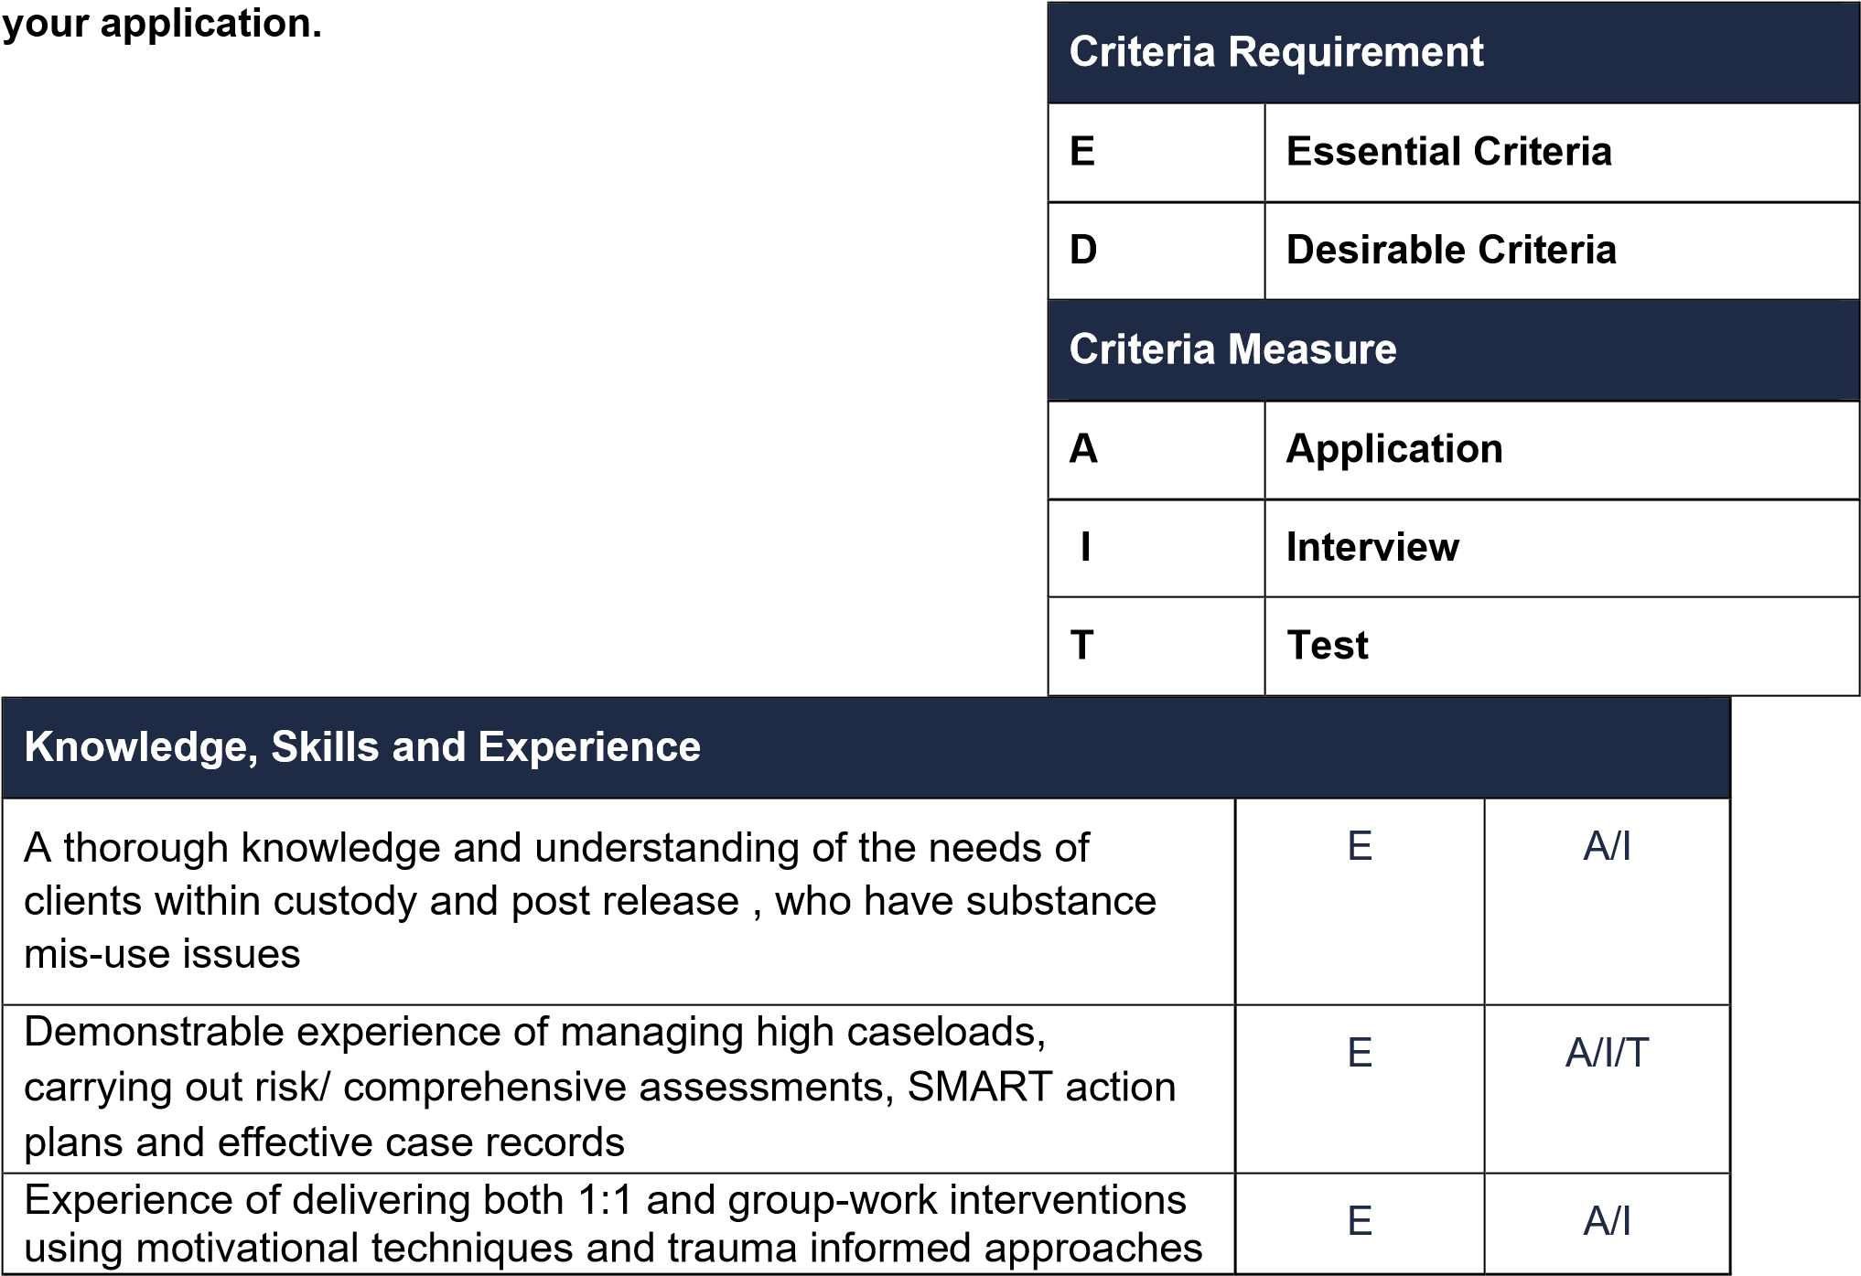

Experience of working with treatment and/or criminal justice services | E | A/I
The ability to set and stick to professional boundaries | E | A/I
Ability to work effectively with key partners in order to successfully deliver outcomes | E | A/I
Demonstrate the ability to organise workload, ensuring effective time management and prioritisation to meet targets | E | A/I
Understanding of, and commitment to, the principles of equal opportunity and GDPR requirements including client confidentiality | E | A/I
Driving licence and access to a car (the role will require visits to all prisons in and provide meet and greet for release) | E | A/I
Ability to work autonomously and confidently in a secure setting | E | A/I
Experience of using electronic case management systems and efficient with Microsoft Word, Outlook, teams. | E | A/I
Personal experience of addiction/imprisonment (Addicts in recovery should have at least 3 years clean time. Ex-prisoners, should have been released at least 5 years ago). | D | A
Experience of providing counselling services to prisoners, or those with Health and Wellbeing, or drug and / or alcohol problems | D | A
A thorough knowledge of and commitment to the 12-step process of recovery from addiction/recovery agenda | D | A/I
Personal Attributes
Proactivity – Quick thinking with a high level use of initiative | E | I
Resilience – Solves problems, takes learning on board from mistakes to aid personal and professional growth | E | I
Adaptability – Can work in fast-paced changing environments | E | I
Confidence – Has confidence in own abilities, has good eye contact and able to communicate clearly and concisely | E | I
Team Work – Works in harmony with colleagues to deliver results | E | A/I
Open to Feedback - Open to constructive feedback in order to further develop | E | I
Qualification
Level 3 substance misuse related /or criminal justice qualification of substance misuse services or relevant experience in a comparable role | E | A/I
Any qualification in advice & guidance, counselling or PTTLLS | D | A
Previous experience as a subject matter experts (SME) in particular vulnerable groups (e.g. BAME) or needs (e.g.  chemsex), | D | A/I

Forward Trust Vision, Mission, and Values:
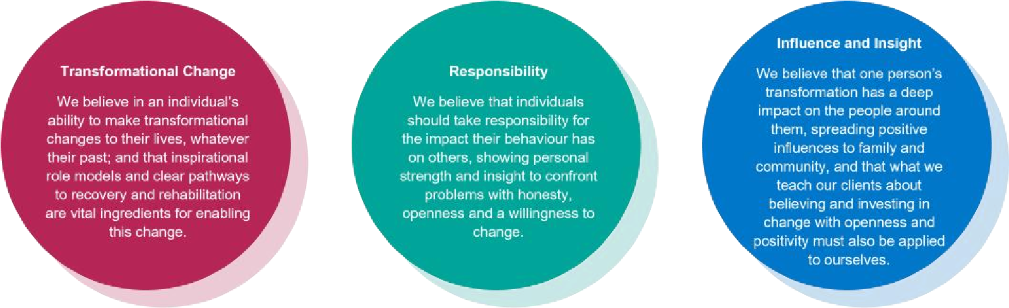


Our Values:

