**Forward Trust Job Description**

|  |  |  |  |
| --- | --- | --- | --- |
| **Position Title** | **Recovery Navigator** | **Reports to** | **Team Leader** |
| **Locations: Enfield & Haringey, Camden & Islington, Harrow & Barnet (Cluster 1)** | | | |

|  |
| --- |
| **Introducing Forward Trust:** |

We are Forward, the social enterprise that empowers people to break the cycle of crime or addiction to move forward with their lives. For more than 25 years we have been helping people to build positive and productive lives, whatever their past. We believe that anyone is capable of lasting change. Our services have supported thousands of people to make positive changes and build productive lives with a job, family, friends, and a sense of community.

Forward Trust deliver Commissioned Rehabilitative Services (CRS), directly for HMPPS. Currently we deliver Accommodation, Dependency and Recovery and Personal Wellbeing. Accommodation is delivered in Dyfed-Powys, South Wales and Gwent. Dependency and Recovery in London and Yorkshire and The Humber. Personal Wellbeing in Bedfordshire, Cambridgeshire, Essex, Lincolnshire, Norfolk, Sussex, Surrey; and as a subcontractor in Kent and Cheshire.

|  |
| --- |
| **Role and Team Overview:** |

As a **Recovery Navigator** in the London Dependency and Recovery Service, you will be working within a hybrid model as part of a flexible, multi-disciplinary team, travelling across the probation delivery units in the boroughs of: **Enfield & Haringey, Camden & Islington, and Harrow & Barnet.** This is an in-person service, and you will be expected to work day-to-day from the locations mentioned above.

The service is designed to improve engagement of Person(s) on Probation into treatment services and ‘bridge the gap’ between probation and substance misuse services in the community by offering practical assistance and ongoing support through a range of timebound, enforceable and motivational interventions.

You will carry a diverse caseload of adult male prison leavers and those on community orders within the National Probation Service, supporting to implement their action plan and navigate their recovery journey. You will be responsible for completing comprehensive assessments, creating a collaborative action plan and delivering one to one, group work/virtual sessions, whilst maintaining accurate record keeping throughout.

Your role is to successfully navigate these men on their recovery journey by providing:

* Support and advocacy e.g. including physical help with referral forms, face-to-face negotiations with a wide range of other providers, attending appointments with them or taking steps on their behalf, for example making phone-calls and onward referrals.
* Advice, guidance and information e.g. Information via a variety of forms (including printed documents, one to one session, group session, online session or a combination of any of the above) but must be provided in a way that enables the Person(s) on Probation to act on the information given and should form part of a wider package of support offered.
* Deliver interventions to empower and upskill Person(s) on Probation to enable understanding and management of their Dependency and Recovery needs.

This service should not duplicate provision where commissioned Substance Misuse Services are already in place, instead we will work to ensure access and sustained engagement with statutory and existing services to achieve controlled dependent behaviour or abstinence with the aim to reduce re-offending.

Recovery Navigators will be multi-skilled to provide a range of support/interventions across all complexity levels and be able to work across London, providing flexibility and resilience against changing demand.

Some Recovery Navigators will have an opportunity to become subject matter experts (SME) in particular vulnerable groups (e.g. BAME) or needs (e.g. chemsex), providing support to colleagues across the team.

You will be responsible for adhering to the targets set by Forward and the local commissioners. Co-operative working relationships with other partner agencies and probation staff are vital to this role.

Some degree of flexibility may be required if out of office work is required, but this is a predominantly a Monday - Friday 09:00-17:00 role.

You may at times be required to attend our head office for training or support in other areas of London.

|  |
| --- |
| **Principal Accountabilities:** |

## **Service Delivery**

* Carry out comprehensive substance misuse and risk assessments, create collaborative action plans with clients and conduct sessions on a consistent basis.
* Deliver both 1:1 sessions and group work/programme facilitation as identified on action plan.
* Maintain high quality, detailed electronic records as per requirements of the Refer and Monitor system.
* Build and maintain effective working relationships, communication and liaison with all stakeholders; including sign posting to relevant agencies to enhance client access and support.
* Work closely with probation and substance misuse services.
* Supporting with client attendance to community appointments.
* Participate and contribute in key meetings such as team meetings and multi-disciplinary reviews, sharing information appropriately.
* Update the Refer and Monitor system daily with information indicating changes in risk including:
  + Non-attendance.
  + Poor engagement with activity.
  + Threatening behaviour.
  + Safeguarding concerns.

## **Performance Management**

* To comply with contractual service level agreements/key performance targets, ensuring all timeframes are met as per contractual obligations.
* Ensure D&R interventions are facilitated to the standard required by Forward Trust and authority in accordance with any relevant manuals/framework.
* Plan and manage caseload effectively, making sure that clients are prioritised appropriately and seen in a timely manner.
* Contribute to the overall smooth running of the service by being proactive and solution focused.

## **Quality and Safety**

* Raise/report safeguarding concerns in a timely manner to statutory agencies; including alerting Probation and all designated safeguarding leads to any risks identified.
* Follow all policies ensuring effective and immediate record keeping where applicable.
* Actively input into multi-disciplinary reviews for clients where required.
* Maintain all client records in an accurate, clear, professional and legible manner.
* Ensure any interaction pertaining to clients is documented on all records.
* Alert the Team Leader/manager immediately to any significant risks or problems arising or observed within the services.
* Effectively manage information, particularly confidential information, within statutory duties and information governance policies.
* Promote and ensure departmental compliance with all relevant legal, regulatory, and ethical responsibilities.
* Ensure all incidences/near misses are reported via Ulysses system in accordance with policy
* Ensure adherence to lone working policy and local processes.

## **Administration**

* Ensure case management documentation is maintained to the expected audit standards.
* Ensure data capture systems are fully accurate and completed on day of activity.
* Complete and maintain SMART action plans and assessments to the required standards.
* Complete session feedback and end of service reports as per required framework.
* Complete signposting/referral forms as required.

## **Systems and Policy**

* Use IT efficiently to support your role.
* Ensure you have agreed working protocols set between multi-disciplinary agencies and share information appropriately.
* Make full use of the information systems available to you such as Intranet, email.
* Save all relevant work on SharePoint.
* Report any issues relating to IT as per process.
* Maintain any Cascade System requirements you are responsible for on the HR personnel system.
* Ensure during induction period you familiarise yourself with all Forward Trust policies.
* Keep up to date with relevant legislation changes, best practice and read all communication received.

## **Other**

* Take on other reasonable tasks and responsibilities as deemed appropriate by Line Management.
* To actively identify any training requirements, continued professional development and support needs and inform line manager.
* To independently support with delivery at any mandated delivery location.

|  |
| --- |
| **Required Skills and Competencies** |

|  |  |
| --- | --- |
| **Criteria Requirement** | |
| **E** | **Essential Criteria** |
| **D** | **Desirable Criteria** |
| **Criteria Measure** | |
| **A** | **Application** |
| **I** | **Interview** |
| **T** | **Test** |

**Below is a list of the criteria required to apply for this role; please address each of these points in your application.**

|  |  |  |
| --- | --- | --- |
| **Knowledge, Skills and Experience** | | |
| Knowledge and experience of the criminal justice sector. | E | A/I |
| Excellent experience of substance misuse field and/or experience of working in a related field or similar field | E | A |
| Demonstrable experience of managing high caseloads, carrying out risk/ comprehensive assessments, SMART action plans and effective case records | E | A/I/T |
| Experience of delivering both 1:1 and group-work interventions using motivational techniques and trauma informed approaches | E | A/I |
| Experience of working with treatment and/or healthcare services | E | A/I |
| The ability to set and stick to professional boundaries | E | A/I |
| Ability to work effectively with key partners in order to successfully deliver outcomes | E | A/I |
| Demonstrate the ability to organise workload, ensuring effective time management and prioritisation to meet targets | E | A/I |
| Understanding of, and commitment to, the principles of equal opportunity and GDPR requirements including client confidentiality | E | A/I |
| Experience of strong communication skills with people from a range of backgrounds in a sensitive, supportive and professional manner | E | A/I |
| Personal experience of addiction/imprisonment (Addicts in recovery should have at least 3 years clean time. Ex-prisoners, should have been released at least 5 years ago). | D | A |
| Experience of providing counselling services to prisoners, or those with Health and Wellbeing, or drug and / or alcohol problems | D | A |
| A thorough knowledge of and commitment to the 12-step process of recovery from addiction/recovery agenda | D | A/I |
| Knowledge of the Recovery Agenda. | D | A |
| **Personal Attributes** |  |  |
| **Proactivity** – Quick thinking with a high level use of initiative | E | I |
| **Resilience** – Solves problems, takes learning on board from mistakes to aid personal and professional growth | E | I |
| **Adaptability** – Can work in fast-paced changing environments | E | I |
| **Confidence** – Has confidence in own abilities, has good eye contact and able to communicate clearly and concisely | E | I |
| **Team Work** – Works in harmony with colleagues to deliver results | E | A/I |
| **Open to Feedback** - Open to constructive feedback in order to further develop | E | I |
| **Qualification** |  |  |
| Level 3 substance misuse related qualification/working knowledge of substance misuse services or relevant experience in a comparable role | E | A/I |
| Any qualification in advice & guidance, counselling or PTTLLS | D | A |
| Previous experience as a subject matter experts (SME) in particular vulnerable groups (e.g. BAME) or needs (e.g. chemsex), | D | A/I |

|  |
| --- |
| **Forward Trust Vision, Mission, and Values:** |

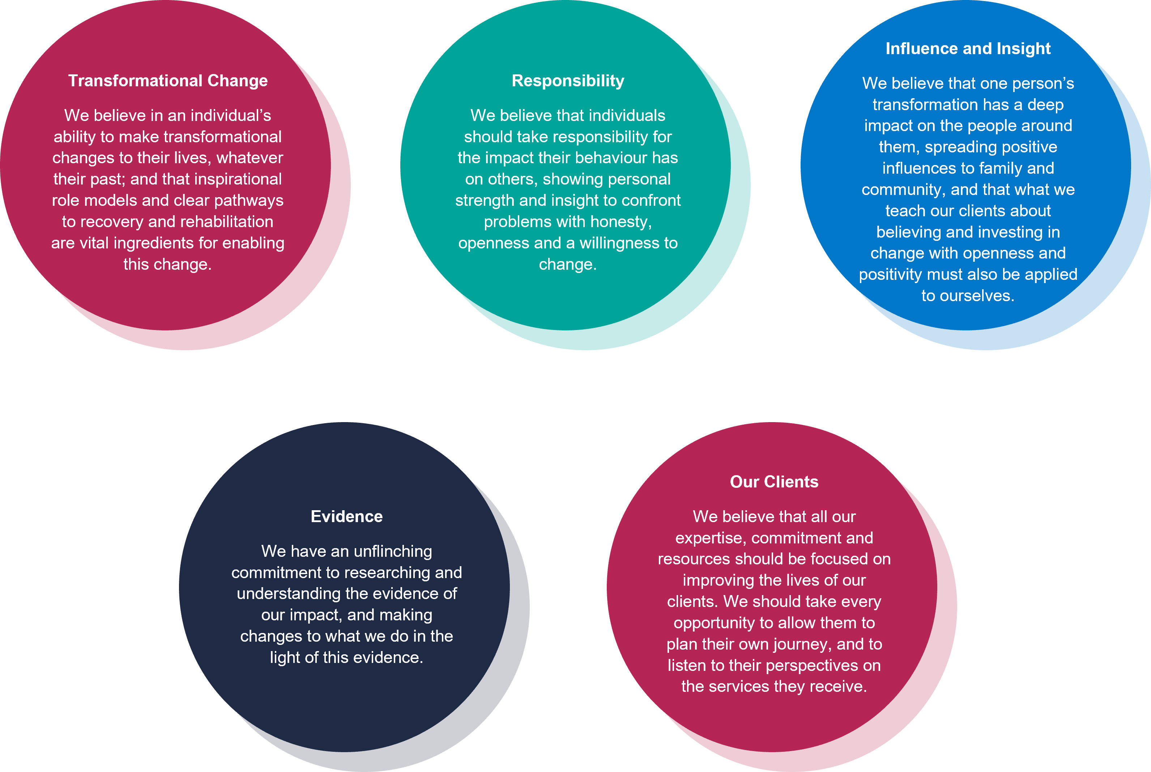

**Our Values:**