**Forward Trust Job Description**

|  |  |  |  |
| --- | --- | --- | --- |
| **Position Title** | Data Administrator | **Reports to** | Senior Administrator |
| **Location:** Working remotely for the Probation Service contracts | | | |

**Introducing Forward Trust:**

We are The Forward Trust (formerly RAPt and Blue Sky), the social enterprise with charitable status that empowers people to break the often interlinked cycles of crime and addiction to move forward with their lives. For more than 30 years we have been working with people to build positive and productive lives, whatever their past. We believe that anyone is capable of lasting change. Our services have supported thousands of people to make positive changes and build productive lives with a job, family, friends and a sense of community.

Forward Trust now delivers services within the **Commissioned Rehabilitative Services** (CRS) as part of the Ministry of Justice’s new probation system, procured by Regional Probation Directors to provide flexible, responsive services to help break the cycle of reoffending.

**Role and Team Overview:**

The Data Administrator is responsible for providing a comprehensive business administration service to support the Probation Contract services.

You will be responsible for contributing and monitoring the targets set by Forward and the commissioners. One of the key targets will be measuring outcomes and attendance rates, so cooperative working relationships with other partner agencies is vital to this role. The purpose of this post is to ensure the smooth administration of the service, encompassing some secretarial duties, data entry collection and monitoring systems.

You are required to maintain accurate data submissions, including analysing and auditing of data to identify performance concerns and errors.

This post is a remote working post however you may also be required to attend our head office for training, internal or external meetings as required.

**Principal Accountabilities:**

# Service Delivery

* To contribute to data collection and ensure the collection of relevant statistical data is accurate.
* To use initiative to ensure all administration systems and processes are effective in producing the best possible support for the Probation Contract services.
* Build strong relationships with, colleagues across all geographical locations within the Probation Service contracts and make full use of the support offered by line management and head-office functions.
* Support the Service by ensuring all tasks are covered and undertaken to a high standard.
* In conjunction with admin team, to act as the single point of access for the Probation service contracts.
* Ensure updated directory of all staff and key contacts.

# Performance Management

* To work with Microsoft Excel, Word, Outlook and any other identified systems.
* To be responsible for answering the phone and dealing with enquiries as appropriate. Using own initiative when dealing with a range of subjects in a courteous and efficient manner, whether in person, writing or telephone, always taking client confidentiality into consideration.
* To assist with maintenance of the Probation services administration records in an orderly and user-friendly system.
* To co-ordinate and liaise all relevant communications with the project.
* To coordinate attendance and invite letters, for service delivery activity
* To take minutes in mtgs as and when required, whilst also maintaining action logs.
* To liaise, where appropriate, with relevant prison and Probation departments.
* Engage positively in team meetings, supervision and quarterly line management sessions as required by your line manager.
* Monitor and manage the functional mailbox to ensure all queries are dealt with.
* To maintain confidentiality and data protection principles, raising any issues with line Manager as appropriate and maintaining yearly GDPR training.

# Quality and Safety

* Raise/report safeguarding concerns in a timely manner.
* Follow all policies ensuring effective and immediate record keeping where applicable.
* Ensure any interaction pertaining to service user is documented on all records if you take any calls.
* Alert the line manager immediately to any significant risks or problems arising or observed within the Probation contract services.
* Effectively manage information, particularly confidential information, within statutory duties and information governance policies/best practice
* Promote and ensure departmental compliance with all relevant legal, regulatory, and ethical responsibilities.
* Ensure all incidences/near misses are reported via Ulysses’ system in accordance with Forward’s risk management protocols.
* Engage with regular service audits ensuring that any issues are escalated and addressed in a timely manner and good practice is effectively shared throughout the service to ensure continuous improvement.
* Abide by all Forward’s policies and procedures and encourage others to do the same.
* Work with the highest regard to health, safety and security
* Ensure that information, including statistical data, for audit, research and reporting purposes, is effectively and efficiently collected, recorded and collated in the assigned area
* Ensure completion of all relevant Information Governance modules and the completion of any required refreshers annually.
* Keep up to date technically on all relevant matters and strive for continuous professional development.

# Administration

* Monitor and maintain the electronic case management system under the supervision of your line manager
* Provide statistical data as required
* Input data, as required, into case management systems.
* In conjunction with line manager to help collate the monthly monitoring statistics and producing relevant reports.
* Review the processes and recommend changes to improve the delivery of the Probation Contract Services

# Systems and Policy

* Work towards Forward’s mission and values within current policies and good practice
* Work within any joint working policies frame-work.
* Use IT efficiently to support your role.
* Make full use of the information systems available to you such as Intranet, email.
* Save all relevant work on share-point if required
* Report any issues relating to IT as per organisational process
* Maintain any Cascade System requirements you are responsible for on the HR personnel system
* Ensure during induction period you familiarise yourself with all Forward Trust policies
* Keep up to date with relevant legislation changes, best practice and read all communication received

# Other

* Take on other reasonable tasks and responsibilities as deemed appropriate by Line Management
* To actively identify any training requirements, continued professional development and support needs and inform line manager
* You may be required to travel to head office and sites for training/meetings

**Below is a list of the criteria required to apply for this role; please address each of these points in your application.**

|  |  |  |  |  |  |
| --- | --- | --- | --- | --- | --- |
|  | **Criteria Requirement** | | | | |
| **E** | | **Essential Criteria** | | |
| **D** | | **Desirable Criteria** | | |
| **Criteria Measure** | | | | |
| **A** | | **Application** | | |
| **I** | | **Interview** | | |
| **T** | | **Test** | | |
| **Knowledge, Skills and Experience** | | | | |  |
| An intermediate certification or demonstrable experience in Microsoft packages. | | | E | A/I |
| Demonstrable experience of working in and providing administrative support for a large team | | | E | A/I |
| Experience of accurately collating statistical information, with an attention to detail and minute taking | | | E | A/I |
| Experience of maintaining electronic record systems | | | E | A/I |
| Excellent written and verbal communication skills, with the ability to deal with people of all levels and to work on own initiative in preparing correspondence. | | | E | A/I |
| Willingness to develop an understanding of the aims of Forward and support the organisations ethos. | | | E | A/I |
| Previous experience of working within a confidential and/or secure environment. | | | D | A/I |
| **Personal Attributes** | | |  |  |
| **Proactivity** – Quick thinking with a high level use of initiative | | | E | A/I |
| **Resilience** – Solves problems, takes learning on board from mistakes to aid personal and professional growth | | | E | A/I |
| **Adaptability** – Can work in fast-paced changing environments | | | E | A/I |
| **Confidence** – Has confidence in own abilities, has good eye contact and able to communicate clearly and concisely | | | E | A/I |
| **Team Work** – Works in harmony with colleagues to deliver results | | | E | A/I |
| **Open to Feedback** - Open to constructive feedback in order to further develop | | | E | A/I |
| **Innovative –** Continually searching for better ways of working | | | E | A/I |
| **Qualification** | | |  |  |
| Educated to GCSE grade C or above in English and Maths or an equivalent or advanced level. | | E | | A/I |
| Holds a Business Studies or equivalent IT qualification or currently/willing to work towards. | | D | | A/I |

**Forward Trust Vision, Mission, and Values:**

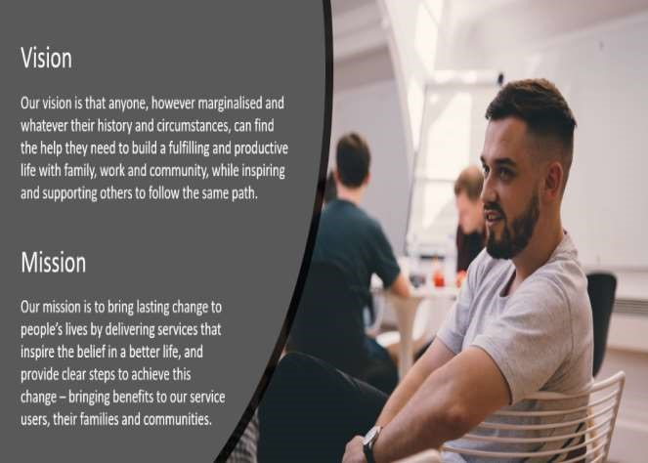

**Our Values:**

