The Forward Trust Job Description

Position Title | Team Leader | Reports to | Service Manager
Location: Hull and East Riding

Introducing Forward Trust

We are Forward, the social enterprise that empowers people to break the cycle of crime or addiction to move forward with their lives. For more than 25 years we have been helping people to build positive and productive lives, whatever their past. We believe that anyone is capable of lasting change. Our services have supported thousands of people to make positive changes and build productive lives with a job, family, friends, and a sense of community.
Forward Trust deliver Commissioned Rehabilitative Services (CRS), directly for HMPPS. Currently we deliver Accommodation, Dependency and Recovery and Personal Wellbeing. Accommodation is delivered in Dyfed-Powys, South Wales and Gwent. Dependency and Recovery in London and Yorkshire and The Humber. Personal Wellbeing in Bedfordshire, Cambridgeshire, Essex, Lincolnshire, Norfolk, Sussex, Surrey; and as a subcontractor in Kent and Cheshire.
Role Overview
As a Team Leader in the Dependency and Recovery Services, you will be working within a hybrid model as part of a flexible, multi-disciplinary team, working in person and travelling across the probation delivery units: Hull, Bridlington, Goole , Beverley and HMP Hull/Humber. This is an in-person service, and you will be expected to work day-to-day from the locations mentioned above.
The service is designed to improve engagement of clients into treatment services and ‘bridge the gap’ between probation and substance misuse services in the community by offering practical assistance and ongoing support through a range of timebound, enforceable and motivational interventions.
You will be managing a team of practitioners who will be delivering the Dependency and Recovery Service to adult males under probation supervision, supporting to implement their action plan and navigate their recovery journey. Just like you, they will build and maintain positive working relationships with their probation practitioner colleagues and all stakeholders involved in their Service User’s care. You will need to be fully embedded within probation offices to promote the work we do.
You will provide visible team leadership, travelling across the locations you are responsible for, attending essential meetings and ensuring smooth project delivery so that your team are providing a high-quality service.
Our service success is dependent on appropriate staff recruitment, development, retention and practice. You are responsible for ensuring that you are highly people focused, providing coaching and all practical supports that enable your staff to thrive in conjunction with service manager.
On a daily basis you will be allocating referrals, managing a small number of complex cases, supporting and developing your team, and ensuring deadlines and quality standards are met. You will be responsible for delivering on performance targets set by Forward Trust and Commissioners. You will support the Service Manager to ensure data accuracy and data submission deadlines are met and services are promoted across the areas you are responsible for to ensure contract volumes are met.
You will have close relationships with Probation Delivery Units, Prisons, Partners, Service Users, Stakeholders, Volunteers and all parts of Forward Trust. You will make every contact matter and keep excellent records.
You will act as the single point of contact and carry out the following activities:
- Develop, maintain and establish relationships/referral pathways by compiling a borough-by-borough directory of services for key contacts, offers and criteria; whilst maintaining an active and appropriately populated Directory of Services.
- Developing strategies to increase the referral volumes into service
- Ensure recovery based social activities are taking place in conjunction with Lived Experience Co Ordinator
- Facilitating ‘town hall’ presentations/deliver webinars to introduce our services and recovery-oriented mission; whilst aligning with local priorities/challenges
- Arranging relevant presentations, Q/A sessions with key members of staff on a service/organisation basis, e.g. Local Authorities (LAs), SMS providers, NHS, Probation, Other CRS providers (digitally/face-to-face)
- Enhance knowledge of and access to voluntary sector support amongst people in criminal justice services.
- Be the single point of contact for Probation communications and other providers.
- Provide written reports and presentations for contract review meetings.
• Map existing community services to improve access to them and identify gaps in provision, including building stronger strategic links with healthcare partners at all levels

At times you will be the most senior representative available and will be required to deputise for the Service Manager to ensure the smooth running of the service. You will be in a position of trust and building an excellent relationship with your manager will be a priority, as well as collaborative working relationships with partner agencies.
Some degree of flexibility may be required if out of office work is needed, but this is a predominately Mon -Fri 09:00-17:00 role.
You will at times be required to attend our head office for training and essential meetings.
Role Responsibilities

Leadership and People Management
- Build strong relationships with colleagues in the Probation Delivery Unit, attending regular team mtgs, promoting the service and offering substance mis use awareness training.
- Positive role model during periods of change (i.e. contract implementation, management changes, new ways of working)
- Develop and maintain relationships with key stakeholders, by representing Forward at regular meetings.
- Support individual development needs for direct reports, providing quarterly line management and probation reviews as a minimum.
- Ensure all interventions are delivered to the required standards by facilitating observed practice sessions, carrying out file checks and providing constructive feedback.
- Support effective case load management, making sure that clients are prioritised appropriately and seen in a timely manner, ongoing care and treatment is reviewed in close liaison with other agencies.
- Motivate the team to ensure KPIs are met and take an active role in implementing and achieving them.
- Manage team performance and dynamics to maintain a positive working environment, working in conjunction with HR and the Service Manager; ensuring all concerns are escalated to Senior Operations Manager.
- Leading by example in self-care and positive attitude , making full use of the support offered by your line manager and Head Office functions.

Service Management
- Oversee and ensure effective management of the areas under your responsibility.
- Compile the service rota and share with all colleagues in the team, ensuring staff are based at probation units.
- Attend and all case management meetings, as well as chair team and performance meetings.
- Lead on and encourage integrated ways of working with partners and ensure a clinic timetable is in place at all probation offices.
- Manage resources effectively in order to meet targets and deadlines in accordance with contractual targets, volumes, outcomes and obligations as described in the Dynamic Framework contract. Prioritising but not limited to:
  - Meeting Service Level One – Assessing a referred Service User on time
  - Meeting Service Level Five – Providing a first intervention on time
  - Meeting volumes and complexities as described in the contract
  - Ensuring Action Plans are delivered in a timely way to a high standard
  - Ensuring appropriate length of support according to complexity, need and Action Plan of the Service User
  - Ensuring quality of the service via excellent supervision
  - Provide mixed modality services: in person, 1:1, groupwork, Lived Experience led, and virtual only where this is the only way to provide a service to the Service User because of circumstances or needs they have.
  - Meet OSAG and HMPPS directed minimum standards for delivery.
- Undertake reviews and adaptation of service delivery model in conjunction with Service Manager to ensure service delivery and targets are met.
- Ensure that interventions are delivered in accordance with the needs of the service users, complying with internal process audits, continually ensuring that contractual obligations are met.
Carry out risk and initial/comprehensive assessments, develop and maintain action planning and complete session and end of service reports.
- Maintain live records as per requirements of the Refer and Monitor system
- Complete reports as requested by line manager
- Build and maintain effective working relationships, communication and liaison with all stakeholders, including sign posting to relevant agencies to enhance access and support.
- Update the Refer and Monitor system daily with information indicating changes in risk including:
  - Non-attendance,
  - Poor engagement with activity.
  - Threatening behaviour.

Quality and Safety
- Carry out regular service audits and develop action plans to ensure that any issues are escalated and addressed in a timely manner and good practice is effectively shared throughout the service to ensure continuous improvement.
- Ensure that information, including statistical data, for audit, research and reporting purposes, is effectively and efficiently collected, recorded and collated in the assigned area.
- Risk identification and management, in liaison with Service Manager. Includes supporting in the quarterly Regional Governance meetings, updating the Risk Register and other SIP documentations.
- Work with the highest regard to health, safety and security in the workplace highlighting any risks (potential or actual) to the Service Manager and (where appropriate) the Head of Governance, in accordance with Forward’s risk management protocols.
- Effectively manage information, particularly confidential information, within statutory duties and in accordance with best practice.
- Promote and ensure departmental compliance with all relevant legal, regulatory, and ethical responsibilities.

Administration
- Ensure case management documentation is maintained to the expected audit standards and kept live with case notes being updated on day of activity.
- Monitor all data input to meet commissioner, prime contractor and reporting requirements via both authority and internal systems.
- Compile data reports for Prime/Commissioner to evidence meeting contractual targets.
- Complete and maintain action plans and assessments to the required standards.
Other
- Take on other reasonable tasks and responsibilities as deemed appropriate by the Service Manager
- Some flexibility of delivery may be required.

Role Criteria
Criteria Requirement
E | Essential Criteria
D | Desirable Criteria
Criteria Measure
A | Application
I | Interview
T | Test
Below is a list of the criteria required to apply for this role; please address each of these points in your application.

Knowledge, Skills and Experience
Demonstrable experience in the management of teams, performance and development. | E | A/I
Genuine interest and experience in motivating and developing people | E | A/I
Experience in key relationship management both internally and externally | E | A
Knowledge and experience of implementing formal procedures and policies | E | A/I
Excellent problem solving and negotiation skills | E | A/I
Project and time management skills | E | A/I
Knowledge of the issues facing service users in the criminal justice sector. | E | A/I
Demonstrable experience of managing high caseloads, carrying out risk/ comprehensive assessments, SMART action plans and effective case records | E | A/I
Previous experience of working in a 12 step primary care programme | D | A
Personal experience of addiction/imprisonment (Addicts in recovery should have at least 3 years clean time. Ex-prisoners should have been released at least 5 years ago). | D | A
Experience of working within the criminal justice sector | D | A
Knowledge of the Recovery Agenda | D | A
Personal Attributes
Proactivity – Quick thinking with a high level use of initiative | E | I
Resilience – Solves problems, takes learning on board from mistakes to aid personal and professional growth | E | I
Adaptability – Can work in fast-paced changing environments | E | I
Confidence – Has confidence in own abilities, has good eye contact and able to communicate clearly and concisely | E | I
Team Work – Works in harmony with colleagues to deliver results | E | A/I
Open to Feedback - Open to constructive feedback in order to further develop | E | I
Qualification
A qualification in Management at Level 3/working towards or demonstrable experience in a comparable role | E | A/I

Forward Trust Vision, Mission, and Values:


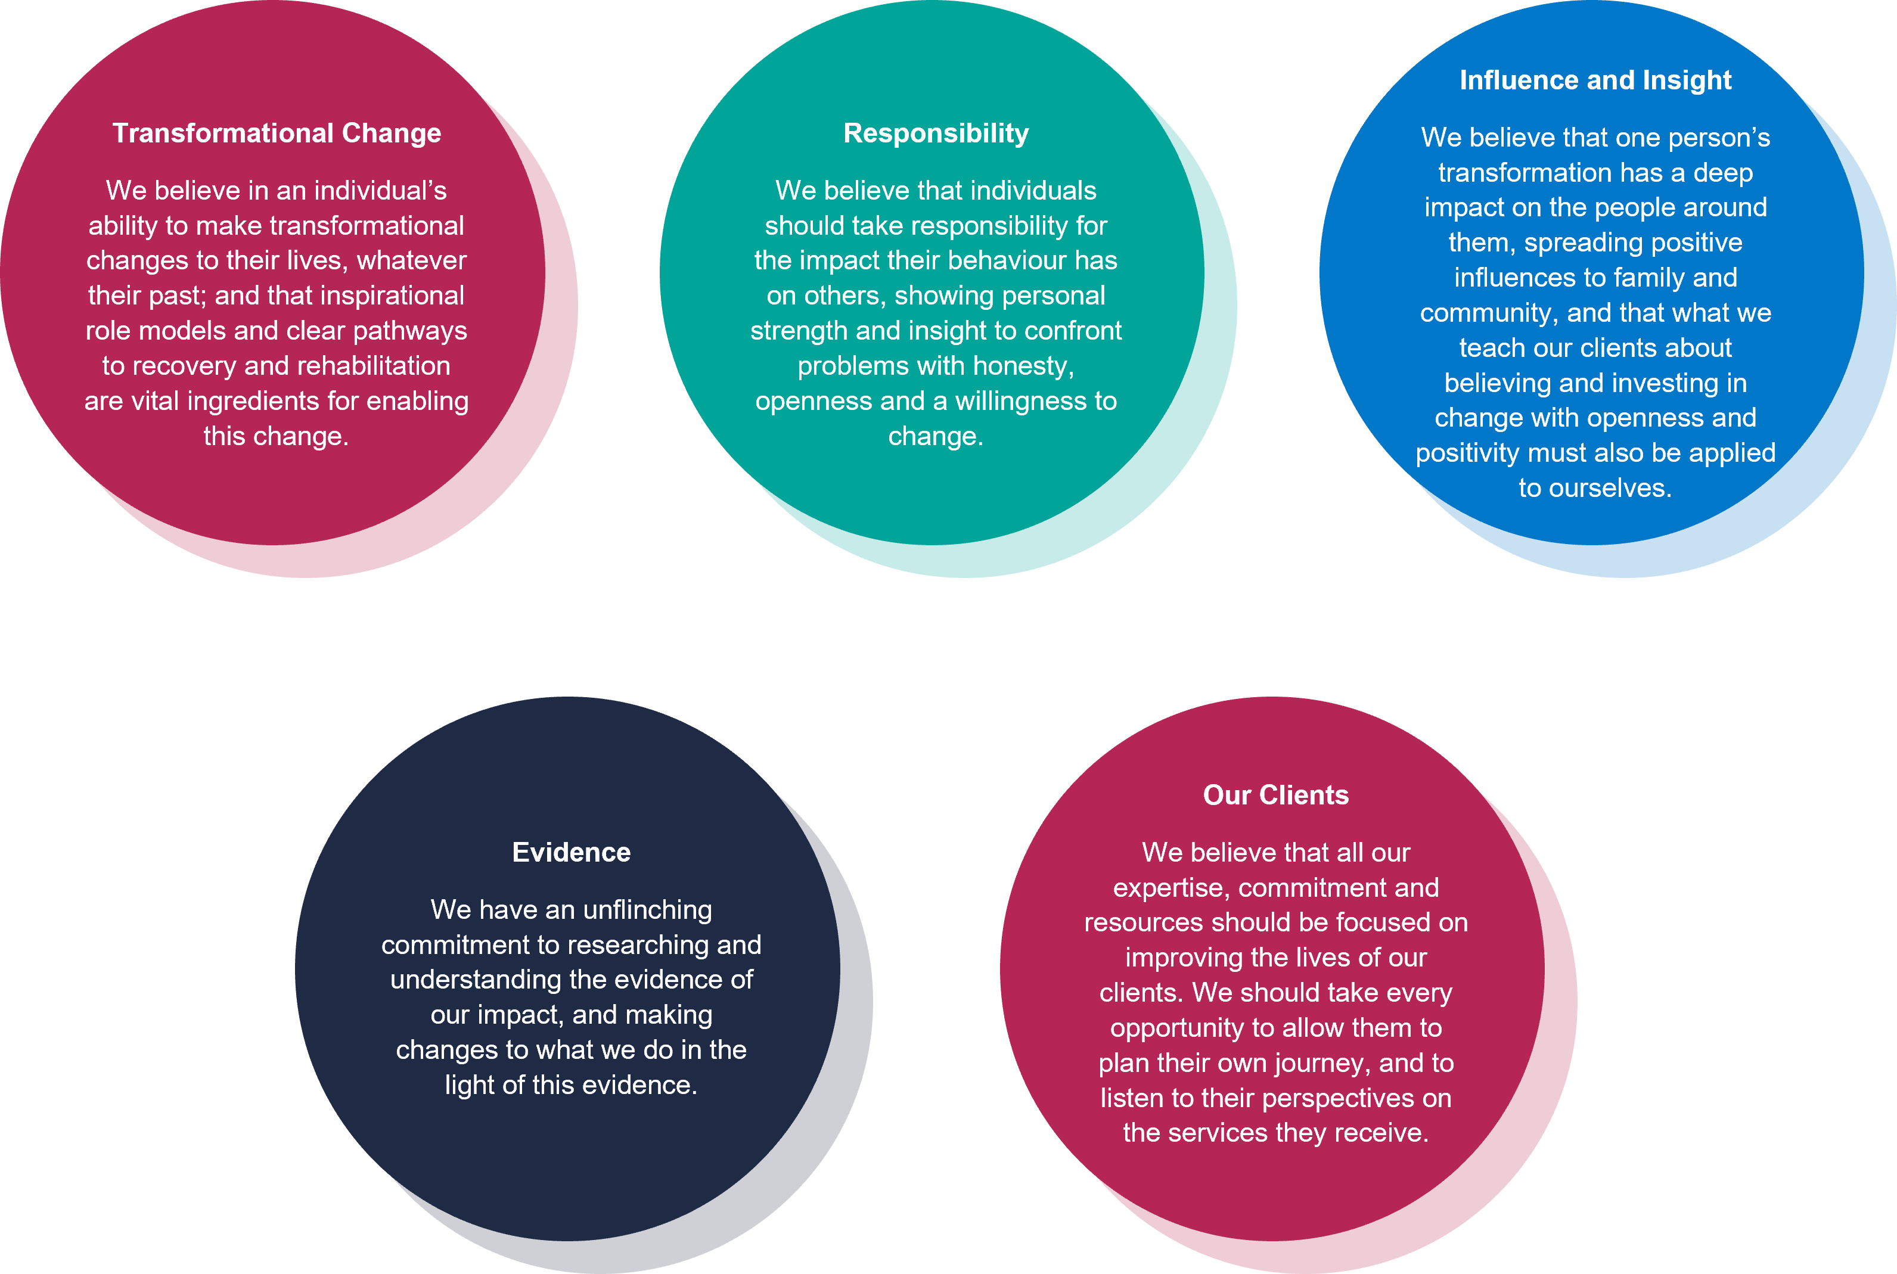
Our Values:

